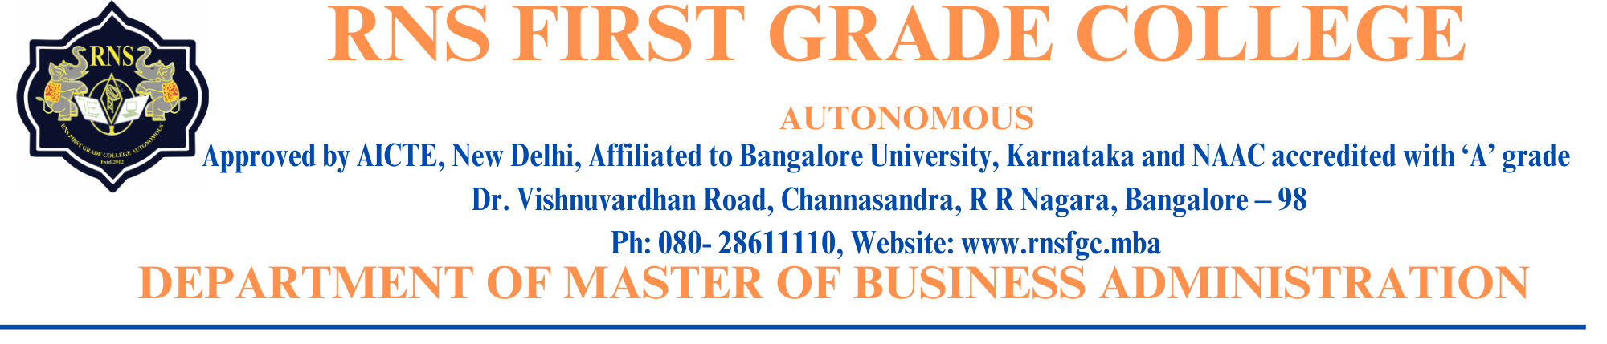

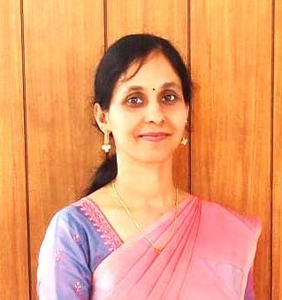

Dr. Mithila K S

**Designation: Assisstant Professor**

**Official Email ID:** ksmithila10@gmail.com

**LinkedIn ID**:

**Profile:**

Dr. Mithila K S is a dedicated academician with a strong background in Economics and Education. She holds a Ph.D. in Economics from Davangere University, awarded in December 2023, and has cleared the KSET (Karnataka State Eligibility Test) in Economics in 2021 from the University of Mysore. She completed her Master's in Economics from K.H. Srinivasa Institute of Post Graduate Studies, LB and SBS College Sagara, affiliated with Kuvempu University in 2019. Prior to her graduate studies, Dr. Mithila K S] earned a Bachelor's in Education (B.Ed.) with a focus on History and Kannada from Kuvempu University in 2010 and a Bachelor's in Arts (BA) in English, Economics, and Political Science from KSOU, Mysore, in 2008.

**Professional Experience and Contributions:**

Dr. Mithila K has a distinguished academic record marked by several notable achievements. She was awarded the prestigious Indian Council of Social Science Research (ICSSR) Doctoral Fellowship for her Ph.D. program in December 2021, a recognition of her exceptional research capabilities. In 2019, she secured the Second Rank in her Master's degree in Economics from Kuvempu University, reflecting her academic excellence. Furthermore, Dr. Mithila K was honored with the "Best Research Paper Presenter" award for her paper titled "Social Media in Higher Education – A Study in Sagar," presented at the National Conference in Shiralkoppa in March 2019.

**Academic Excellence and Research:**

Her Ph.D. research, guided by Dr. K.B. Rangappa, Senior Professor at Davangere University, is titled “An Economic Study on Utilization of Agricultural Waste in Malnad Region of Karnataka.” This work explores how agricultural crop waste can be leveraged to enhance soil health, increase crop yields, reduce pollution, and promote sustainable agricultural practices using conservation agriculture technologies in the Malnad region of Karnataka. In addition, her Master's thesis, titled “Multiplex Fertilizer Company and Corporate Social Responsibility – A Study in Sagar Taluk,” investigates the voluntary actions of fertilizer companies that go beyond the legal requirements, focusing on their long-term commitment to integrating economic, social, and environmental impacts into their operations. These research projects reflect Dr. Mithila K’ dedication to addressing important socio-economic issues and her contributions to the field of economics.