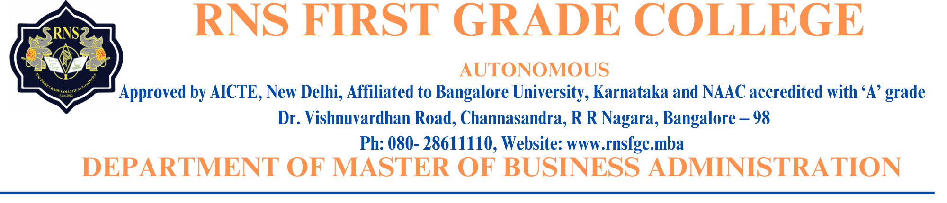

Prof. NIKHIL M N

**Designation:** Assistant Professor

**Official Email ID:** [masternikhilmn@gmail.com](mailto:masternikhilmn@gmail.com)

[nikhilmn_mba@rnsfgc.edu.in](mailto:nikhilmn_mba@rnsfgc.edu.in)

**LinkedIn ID**: <http://www.linkedin.com/in/nikhil-m-n-2563b969>

**ORC ID:** 0009-0007-9890-0902

Mr. Nikhil M. N. is an accomplished academician, researcher, and educator with a rich academic background and diverse teaching experience. A Post-Graduate in Commerce from the University of Mysore, he specializes in Cost and Management Accounting. His academic excellence is marked by his achievement of securing the First Rank in the 2018 batch of Mysore University, along with four Gold Medals, breaking all previous records.

He is currently pursuing his Ph.D. under the guidance of Dr. Y. MuniRaju, Senior Professor at Mangalore University, with a focus on Commerce. Apart from his academic qualifications, Mr. Nikhil has also pursued a Post Graduate Diploma in Business Administration and Human Resource Management.

Mr. Nikhil M. N. stands out as a multifaceted individual with an impressive academic track record, a passion for research, and a strong commitment to shaping the future of his students. His contributions to the academic community, both as a teacher and a researcher, along with his leadership and extracurricular accomplishments, make him a respected figure in the field of Commerce and Management education.

**Professional Experience and Contributions:**

Mr. Nikhil has built an impressive career in academia, contributing both as a teacher and a researcher. He worked as an Assistant Professor at Sree Cauvery First Grade College, Mysore, and as a Faculty at FMKMC College (A Constituent College of Mangalore and Kodagu University), Madikeri, where he also served as an NSS Assistant Officer. His teaching expertise spans various aspects of commerce, management, and human resource management. He is currently an Assistant Professor in the Department of Post Graduate Studies in Business Administration (MBA) at RNS First Grade College Autonomous, a prestigious institution affiliated with Bangalore University. RNS First Grade College is part of the esteemed RNS Group of Institutions, which has a reputation for excellence in education.

**Academic Excellence and Research:**

Mr. Nikhil’s academic journey has been marked by a strong commitment to research and intellectual engagement. He has published several research papers in reputed journals and presented at numerous conferences and seminars, contributing to the academic discourse in Commerce and Management. He has also played a key role in organizing and facilitating academic events, including International Conferences, workshops, and National Level Fests. His leadership skills were evident when he served as the Jury Member for various Commerce and Management Fests across Mysore, Kodagu, and Mangalore. As a recipient of the Karnataka State Assistant Professors Eligibility Test (KSET), is qualified to teach at the university level, further cementing his role as a leader in higher education.