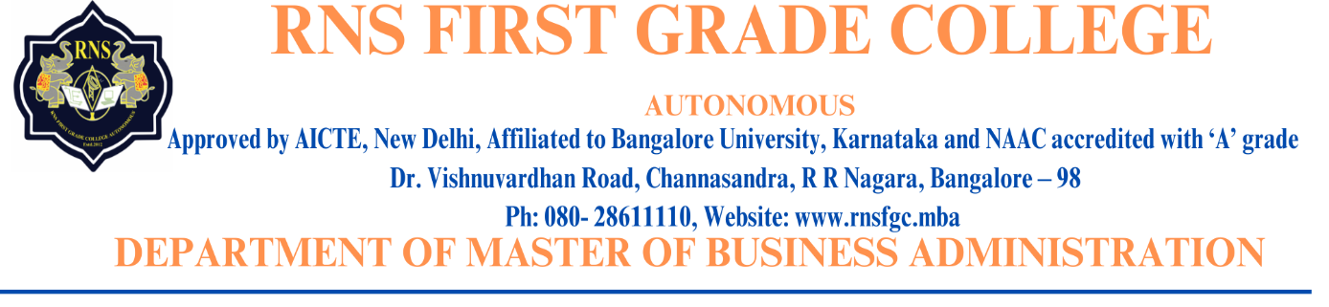

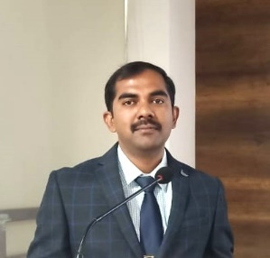 **DR. MADHUSUDHAN T K**

**Designation:** Associate Professor and Placement Head

**Official Email ID:**[madhutk86@gmail.com](mailto:madhutk86@gmail.com)

[PLACEMENTS@rnsfgc.edu.in](mailto:PLACEMENTS@rnsfgc.edu.in)

**LinkedIn ID:** [*www.linkedin.com/in/dr-madhusudhan-t-k-5a976a39*](http://www.linkedin.com/in/dr-madhusudhan-t-k-5a976a39)

**Profile:**

* Dr. Madhusudhan T K is a management graduate with good experience of around 13 plus years in Academia and industry. He completed BSc from Kuvempu University, MBA from RNSIT and Ph.D. from Visvesvaraya Technological University (VTU), Belagavi
* Dr. MadhusudhanT K is heading the Placement Department at RNSFGC and helping the students through career guidance and working closely with the industries to bridge the gap between the academia and corporate.
* Dr. MadhusudhanT K is also a soft skills trainer and helping the rural students in training and placement. Since past 4 years providing the training and placement assistance to RNSFGC- Murudeshwara students
* Authored a book on Environmental Studies, a compulsory course to all the UG students of Karnataka state prescribed by UGC. Reviewed the book on Personality Development published by Skyward Publishers
* Dr. MadhusudhanT K guided many students in their projects and internships.
* In the past years, he has served in various committees at the institute level.
* Currently he is working as Associate Professor and Placement Head at RNS First Grade College in the Department of Master of Business Administration (MBA), a renowned Institution affiliated to Bangalore University which is part of prestigious RNS group of Institutions.

**Research:** He has presented and published research articles in national and international conferences and refereed journals respectively.