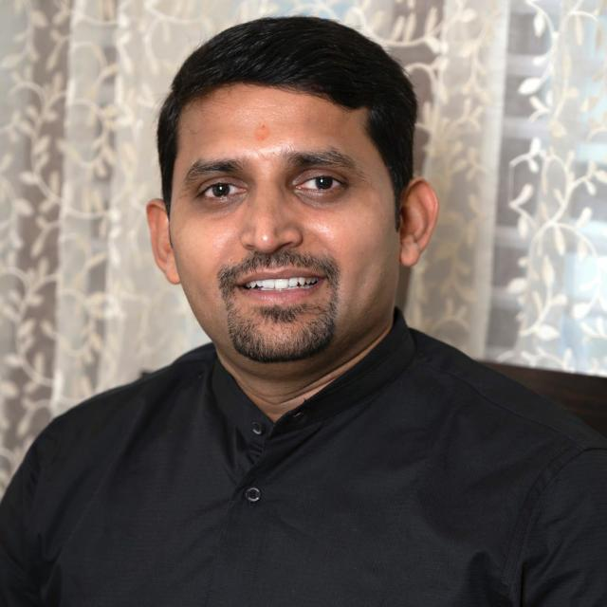 **DR. SHEKAR H S**

**Designation:** Principal and HOD

**Official Email ID:** [principal_rnsfgc@rnsgi.com/](mailto:principal_rnsfgc@rnsgi.com/)

hodmba_rnsfgc@rnsgi.com

**LinkedIn ID**: Shekar Hosur Shivaram

**ORC ID:** 0000-0003-3444-8607

**Profile:**

* Dr. Shekar H.S is a commerce graduate with good experience of around 15 plus years in Academia and industry. He completed BCom (Hons) from Sri Sathya Sai Institute of Higher Learning, Whitefield, one of the top colleges in India, MBA from Bangalore Institute of Technology and Ph.D. from Visvesvaraya Technological University (VTU), Belagavi and his research centre was BMS College of Engineering, Bangalore.
* Dr. Shekar H.S is the Life Member of BMA (Bangalore Management Association). He has served as member of the BOE (Board of Examiners) of VTU.
* Dr. Shekar H.S is offering management consultancy services to local Businesses and entrepreneurs as well. He has also worked for the ED Cell and Incubation centre in his previous institutions and has suitable entrepreneurial experience.
* Dr. Shekar H.S has been part of training sessions on Human values; Building Entrepreneurial Skills; Leadership skills; Professional etiquettes, Self-discipline for success and more.
* Dr. Shekar H.S worked as the Professor and HOD in the Department of Management Studies at KS School of Engineering and Management, Bangalore, Karnataka from Feb-2022 till September-2023 – One of leading Management Institutions in Karnataka. During his tenure, the Institution bagged University Rank and introduced many initiatives for the holistic development of students and the overall growth of the department and grew across all fronts. This resulted in recognitions like one of the top MBA colleges in India by the Times of India Ranking.
* He has supervised numerous administrative interns during the past years and has served on various committees at the institute level.
* Currently he is working as Professor and HOD at RNS First Grade College in the Department of Master of Business Administration (MBA), a renowned Institution affiliated to Bangalore University which is part of prestigious RNS group of Institutions.

**Research:**

* Dr Shekar H.S is a VTU registered Research Supervisor in Business Administration and is currently guiding 2 research scholars at KS School of Engineering and Management Research Centre. Under his guidance 2 scholars have been awarded PhD.
* He has presented and published research articles in national and international refereed
* journals. He has worked for the funded research projects of ICSSR.