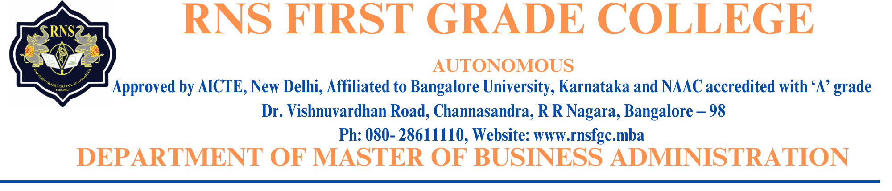

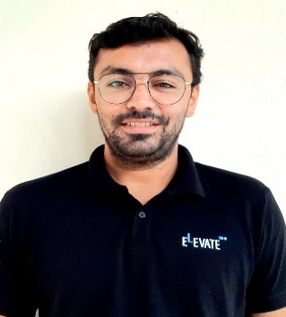 **Prof. Karthik C**

**Designation:** Professor

**Oficial Email ID:** [karthik.c@datastride.ai](mailto:karthik.c@datastride.ai)

**LinkedIn ID**: karthik-chandrashekar-11756baa

**Profile:**

I am a seasoned professional with 12 years of work experience in multiple

industries. Having worked in different levels of businesses, He strong blend

of technical expertise and management acumen.

**Skills:**

Root cause analysis | Product management | Strategy development | Business evaluation |

Financial planning | Operation management | MS office | Content development | Soft skills |

Customer engagement

|  |  |
| --- | --- |
|  |  |
| **Work Experiance** |  |
| 06/2023 - Present | Co-Founder & COO at **Datastride Analytics**  Implementing product development strategy, Fundraising, Sprint master, Financial Operations & management, Risk management, and Customer engagement. |
| 01/2022 – 06/2023 | Product owner and Manager at **Drishi**  Gamification of Education, Student & Employee training, Ideation & Brainstorming, and Project management |
| 01/2019 – 01/2022 | Content developer and Manager at **BYJUS**  Development of content, Data management, and Strategy development |
| 06/2017 – 12/2018 | **Educator, Mentor & Consultant**  Trained and mentored students from K12 and degree background on Science, Mathematics, and Career Management & Planning. | |
| 02/2017 – 03/2019 | Co-Founder and COO at **Avid Athletes**  Developed & implemented curriculum on sports education and maintained logistics at 6 schools. | |
| 06/2015 – 06/2016 | Assistant Teacher at **HSRW, Kleve, Germany** | |
| 01/2015 – 01/2017 | Assistant Engineer at **Polyoptics GmBh, Kleve, Germany** | |
| 08/2012 – 05/2014 | Application Developer at **IBM, Hyderabad (India)** | |
| **EDUCATION** |  | |
| 10/2008 – 07/2012 | **B.E. – Mechanical Engineering**  Bangalore Institute of Technology, Bengaluru (India) | |