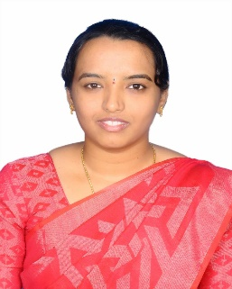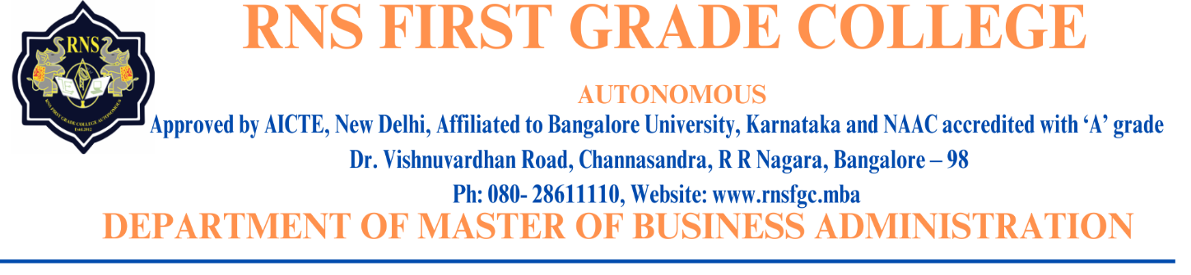

**Prof. LAVANYA**

**Designation:** Assistant Professor

(Visiting Faculty) - RNSFGC MBA

**Official Email ID:** [Lavanyamanjunath95@gmail.com](mailto:Lavanyamanjunath95@gmail.com)

**Profile:**

* Lavanya. M an esteemed scholar, proudly holds a prestigious educational background. She completed B.com from National Degree College, Jayanagar, Bangalore University (Autonomous). Has a Master’s in Business Administration from RNS Institute of Technology, Visvesvaraya Technological University, Belgavi. She is pursuing a Doctor of Philosophy at PES University, Bangalore for the title ‘Role of fintech in lending to RNFS.’ She has 5 years of academic experience in the area of Accounting and Finance. Her teaching subjects include Accounting for Managers, Financial Management, Corporate Valuation & Restructuring, Indian Financial System, and other finance related subjects.
* Lavanya. M has worked as an Assistant Professor in the Department of Management Studies at Don Bosco Institute of Management Studies and Computer Applications, Bangalore, Karnataka from Oct 2017 till Nov 2022.
* Currently working as Visiting Professor and Course Coordinator at Jain Online from Sept 2022 till date. And Visiting Professor at RNS First Grade College in the Department of Master of Business Administration (MBA), a renowned Institution affiliated to Bangalore University which is part of prestigious RNS group of Institutions.

**Research:**

* Lavanya. M is pursuing a Doctor of Philosophy at PES University, Bangalore for the title ‘Role of fintech in lending to RNFS.’
* She has presented research articles in various national level conferences and published two research articles in UGC listed journals.
* ed journals.