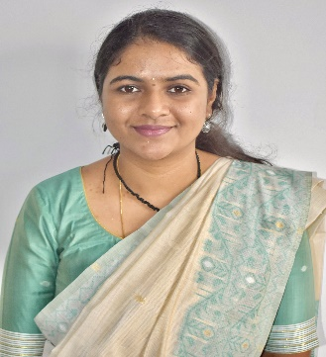**Prof. RAKSHITHA KULKARNI** 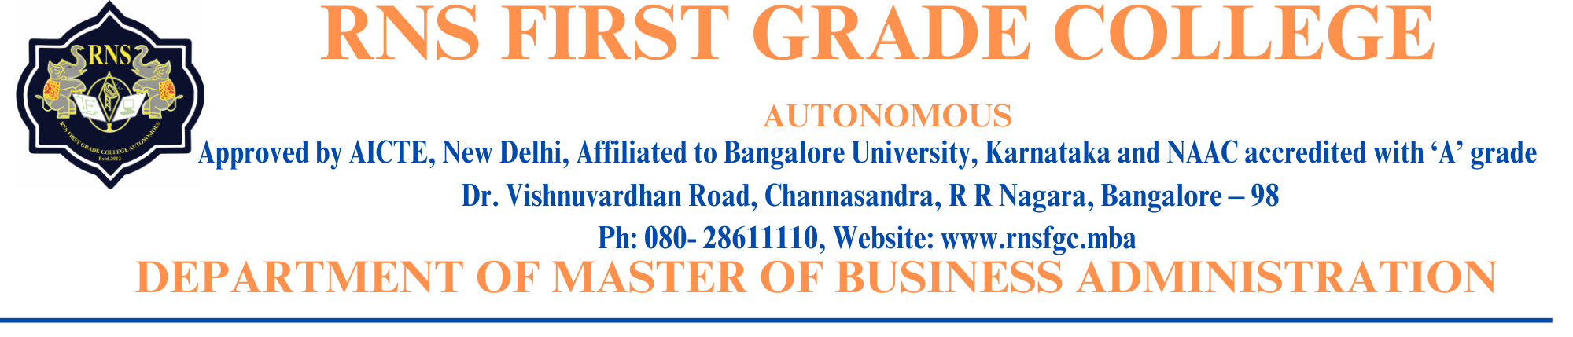

**Designation:** Assistant Professor

**Official Email ID:** [rakshithark.66@gmail.com](mailto:rakshithark.66@gmail.com)

[rakshitha_mba@rnsfgc.edu.in](mailto:rakshitha_mba@rnsfgc.edu.in)

**Profile:**

* Specialized in marketing categories including creative advertising, sponsorship, media, and market research within a marketing agency team.
* Analysed market trends and conducted industry analysis.
* Benchmarked pricing and evaluated contract and negotiation models.
* Recommended suitable agencies for procurement.
* Conducted comparative analyses using benchmark pricing across industries and agencies
* Accumulate and interpret information in the form of in-dept interviews as part of primary market research for NPD
* Analyse data with detail orientation, to identify and solve problems for market

drivers, competitors, demographic needs, pricing features on client’s requirement

for a comprehensive value add.

* Building valid, reliable, interesting, and succinct questionnaire

conforming to the client’s requirement

* Liaison with client’s business partners to assess opportunities, risks, constraints,

strategic business opportunities for our brands

* Data analysis using MS Excel to know the trend
* Provide SMART insights to clients on the concerned pain points
* Maintenance and reporting logs/statuses daily
* Worked for industries such as FMCG, Fintech, health care and e- commerce.

**Achievements:**

* Airwing Cadet of 1 Kar Air Sqdn (Ajmer Nationals Gold and Silver Medal) Vayu Sena Camp (Cadet Warrant Officer).
* "Best Outgoing NCC Cadet" Award from Jain College, RR Nagar, in the year 2014
* Gold Medal for Inter-School Volleyball Competition in the year 2012 conducted by SAI (Sports

Authority of India.

* Organising head of Sports forum 2018-19.
* Directorate Senior (Captain) for Karnataka and Goa in All India Ajmer Trek in the year 2015 – Gold and Silver Medal.
* Organizer of marketing vertical under "Synergy" for Cranium 2018-19 at CMS Business School.
* Joint Secretary of Rotaract Club SBMJC in the year 2017-18.
* Runner-up for "Best Lawyer" in an inter-college competition conducted by MES college.